Request for Proposal for conducting Mid Term Review of
  - Hand in Hand Afghanistan Project (Supporting Rural Entrepreneurship and Promoting Women’s Socio-economic Empowerment) in Dara-e-Suf Bala and Dara-e-Suf Payan Districts of Samangan Province

Overview
Hand in Hand Afghanistan is seeking to procure the services of a suitable consultant to conduct a Mid Term Review (MTR) of the Hand in Hand Afghanistan supporting rural entrepreneurship and promoting women’s socio-economic empowerment in Dara-e-Suf Bala and Dara-e-Suf Payan districts of Samangan Province. The MTR will take place on July 01-15, 2015 and will report the third week of July 2015.

Brief description of Hand in Hand Afghanistan
HiH Af is a Non-Governmental Organization (NGO) in Afghanistan, established in 2007, with the vision to alleviate poverty through job creation. HiH Af promotes economic and social empowerment of the poorest citizens to help them lift themselves out of poverty and vulnerability. HiH Af belongs to the global Hand in Hand network of NGOs with a shared vision to reduce poverty through the creation of sustainable enterprises and jobs. HiH Af has adapted this approach to the unique circumstances in Afghanistan.

HiH Af targets disadvantaged groups in the Afghan society, with focus on women in rural areas who are active in the informal sector. HiH Af’s approach is based on a philosophy of self-help, which provides business and skills training and support to enable poor people, particularly women, to build and sustain independent, market-based economic activities. This provides for a higher level of income for them and their families. This in turn contributes to greater food security, better education for children, increased access to medicines and healthcare and improved housing. To date, in Afghanistan, support is provided to more than 22,000 rural poor in seven provinces. This is done through a 4-step approach:
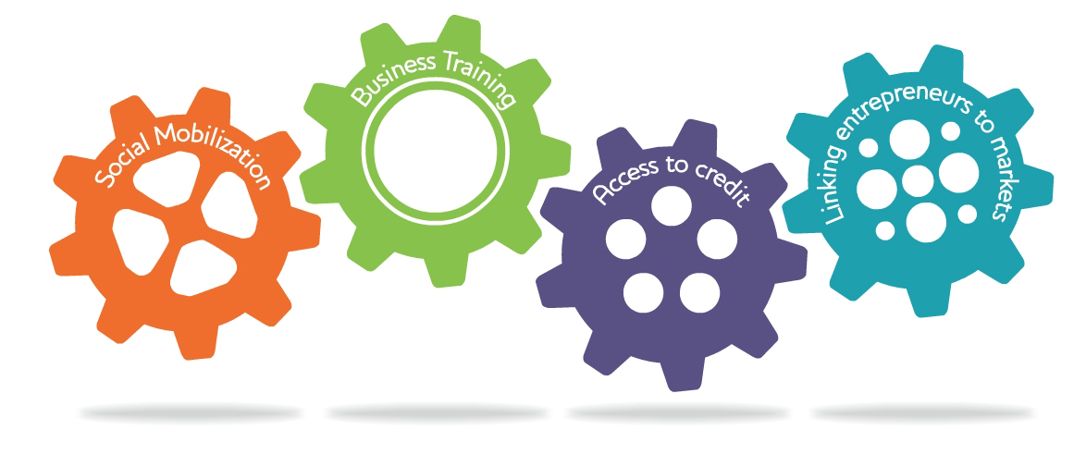

Step1: Group formation and savings mobilization: The first step is consultations with the community to ensure their approval and buy-in. Once buy-in is attained, HiH Af staff support the formation of SHGs based on a predefined set of membership criteria. A group has on average 15 members, each group being either exclusively women or men. Groups are taught the importance of savings and trained in basic finance and cash management. Group savings and internal lending is introduced through pooling regular and discretionary savings and then making short-term loans to members in need.
Step 2 – Entrepreneurship and financial management training: Once mobilization and basic training are completed, members are trained in microfinance and Islamic banking principles, community development activities and promotion of female participation in income generation activities. All members are then taken through Business Development Services (BDS) training, including modules in basic book-keeping, basics of business, marketing, etc.
Step 3 – Access to credit: Experience indicates that over 70% of SHG members who complete the enterprise development module are motivated to start new enterprises or enhance existing ones. The majority are however constrained by lack of capital. For some, access to the internal group savings is enough, but most will over time need access to additional finance. HiH Af is providing essential toolkits for members and working along two approaches to facilitate access to credit for its members once they fulfill basic requirements; whenever possible by linking up with existing MFI partners, or when this is unavailable directly through HiH Af’s Enterprise Incubation Fund (EIF).
Step 4 – Support with market access and value-addition: As a last stage, HiH Af’s staff assesses the needs and aspirations of each group member to access markets and raise the value of their products/services. Based on assessment findings, different types of market linkage and value addition support will be offered.

Brief description of the program
In February 2014, HiH received support from the Delegation of the European Union to the Islamic Republic of Afghanistan to implement a project called “Supporting rural entrepreneurship and promoting women’s socio-economic empowerment in Dara-e-Suf Bala and Dara-e-Suf Payan districts of Samangan Province”. The project is also cofounded by Hand in Hand International and Johnsons & Johnsons Corporate Citizenship Trust. The project aims to strengthen the socio-economic rights of 5,400 poor rural women and men in Afghanistan and economically empower them to create 8,100 jobs, with a particular focus on women. The project has a duration of 2,5 years and will be completed by August 2016.

Mid Term Review (MTR)

General
The MTR will provide an independent assessment of the progress and performance of the program as of 31/May/2015 and of the results obtained compared with the targets and expectations in the Grant Proposal and those set out in the logical frame and work plan.

The MTR will report achievements against the project indicators plus other measures as appropriate. MTR will contain an analysis of any deviation from the logical framework and work plan, reasons therefore and will make comments and recommendations as appropriate.

Specific

Specifically, the MTR will report on the following:

- The activities and indicators, their outputs compared against work plan and logical framework.
- The quality and effectiveness of the activities in achieving the expected outcomes against (minimally) the logical framework indicators plus any other indicators deemed appropriate.
- An analysis of the immediate causes of any deviations in activities and outputs from the logical framework’s targets.
- Expanding on the previous point, an analysis of the issues affecting implementation with reference to:

  - The appropriateness of the HiH model to meeting locally articulated needs
  - HiH Af’s planning and execution of the activity plan,
  - The assumptions set out in the logical framework,
  - The expected and actual behaviour of other actors
  - Any other relevant contextual material

On the basis of this analysis, the MTR will make comments and recommendations as follows:

- Comment on the continued appropriateness of the HiH model to meeting locally articulated needs.
- External factors: Note any new assumptions or risks relevant to the completion of the project, considering both general political, security and environmental factors and specifically the anticipated behaviour of other relevant actors.
- Internal factors: Recommend any changes that should be made by HiH Af to its internal staffing, processes or procedures to ensure successful implementation of the project through to completion. Comment on the plausibility of the work plan through to completion and the likelihood of achieving expected Program outcomes.

Deliverables
- A MTR Plan at the inception stage.
- A presentation of draft findings to both the HiH Af team and the HIH International team for discussion and feedback.
- A MTR Report of no more than 30 pages.
- An Executive Summary of no more than 4 pages.
- Presentation of the MTR Report to a HiH Af/HiH International

Documents and presentations will all be in English.

Tender document
It is anticipated that the MTR would be carried out by a consultancy firm. The lead consultant is asked to tender a proposal document of no more than 4 pages in English by 1600 hours Kabul time on 13 June 2012 electronically to khekmati@handinhand.org.af with copy to arahimnasry@handinhand.org.af.

The proposal should include the following:

- The broad approach
- A short outline methodology for the MTR. This would be expected to include:
  - Review of HiH Af internal procedures, work plans and reports
  - Interviews with key HIH International staff in London via skype or phone
  - Interviews with key HiH AF staff in both Kabul and Mazar, including field staff
  - Interviews with key external stakeholders in Afghanistan (district authorities, Representatives of Provincial Economy and Rural and Rehabilitation Depts and maybe others)
  - Interviews with intended beneficiaries in Dara-e-Suf Bala and Payan districts and visits to activity locations.
- A proposed process and timeframe for the MTR setting out the phases of the MTR, the number of consultants and the number of days.
- The anticipated challenges and dependencies affecting the implementation of the MTR and how these should be addressed both by the consultants, by HIH International and by HiH Af.
- A summary of the skills and experience of the proposed lead consultant and the consultant(s) together with her/his CV showing relevant previous assignments and clients.
- A fee quote for the lead consultant and an estimate for the costs of the Afghan consultant(s).

Consultant skills and experience
HiH Af is looking for a consultant with skills and experience as follows:
- Demonstrable experience of producing high-quality credible Mid Term Reviews and/or Evaluations, supported by familiarity with appropriate methodologies.
- Experience of enterprise development program
- Experience of working in insecure environments
- Excellent knowledge of the Afghan context
- Excellent analytical and people skills
- Excellent writing and verbal communication skills

MTR Process and Timeframe
HiH Af has the following indicative timeframe for the MTR process.

Tender bids deadline: 13 June 2015
Review applications and short list: 18 June 2015
Interview short-listed consultants and appointment of consultant: fourth week of June 2015
Refine methodology, agree timeframe and finalise MTR plan: 30 June 2015
MTR timeframe: 01 July 2015 to 15 July 2015

Within the MTR timeframe:
Presentation of draft findings to HiH Af and HiH Int’l: 22 July 2015
Deadline for receipt of MTR Report and Executive Summary: 26 July 2015
Presentation to HiH Af/HiH International: 29 July 2015

The network today has operations in Afghanistan, Cambodia, India, Eastern Africa and Southern Africa. Strategic support, technical assistance and fundraising are provided by Hand in Hand International in London and Hand in Hand Sweden.

